Unsupervised learning techniques: Training a model only with inputs (no labels)
- Clustering: Takes data without labels and tries to group them into clusters based on common characteristics.
- Anomaly detection: Find unusual data points in a dataset
- Dimensionality reduction: Compress dataset into a much smaller without losing important data.
SVC:
- Shortest distance between the observations and the threshold is called the margin.
  - 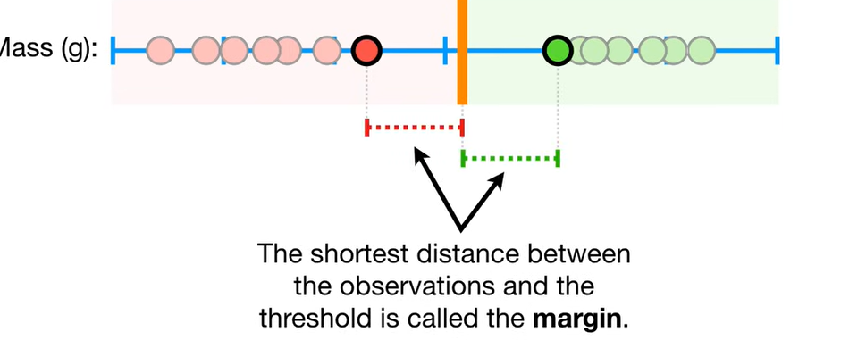
- Maximal Margin Classifier: Using the threshold that gives us the maximum margin between observations (mid-point)
- Bias/Variance tradeoff: Lower bias allows less misclassification, whereas a higher bias allows more misclassification. Higher bias performs better when given new data (low variance), whereas lower bias performs poorly with new data (high variance).
- Soft margin: Margin between threshold and observations
- 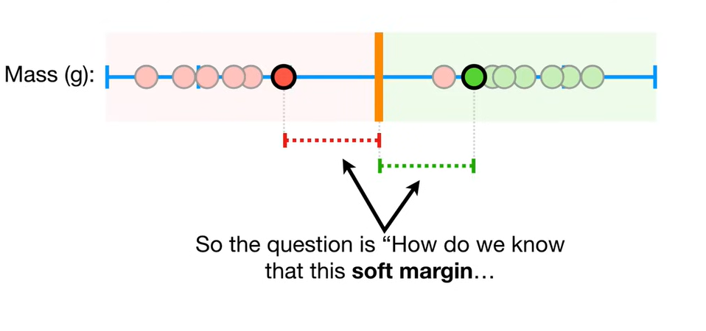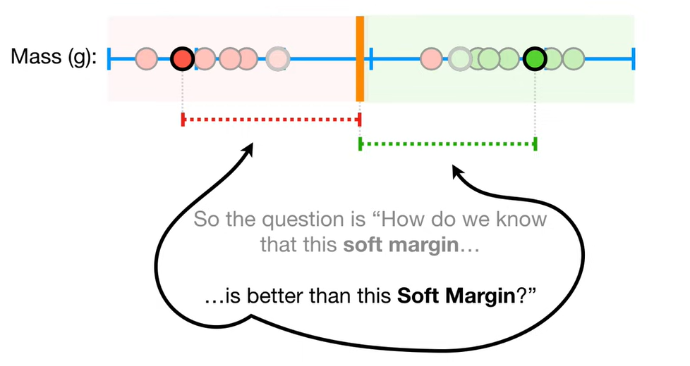
- Cross validation: Determine how many misclassifications and observations to allow inside of the soft margin to get the best classification.
- Soft Margin Classifier (Support Vector Classifier): Using soft margins to determine threshold.
- 2D data:
  - SVC is a line.
  - 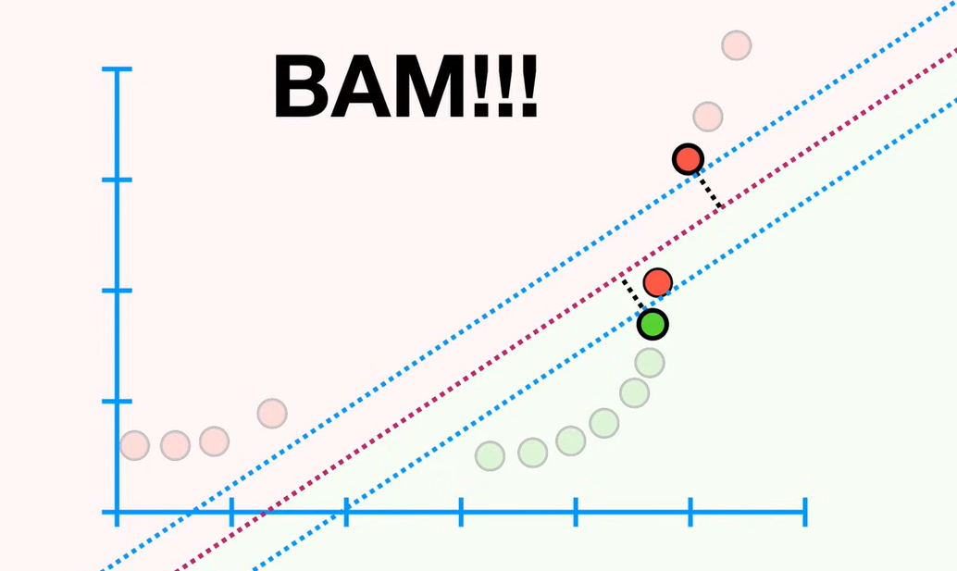
- 3D data:
  - SVC Is a plane
- 4D data:
  - SVC is a hyperplane (flat affine subspace)
Support Vector Machine:
- 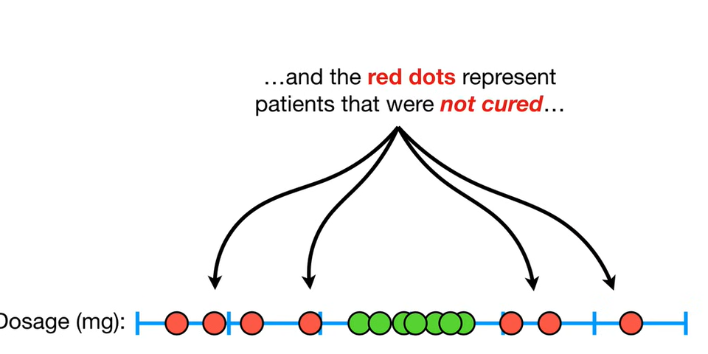 Lots of misclassifications no matter where we put the threshold. We can’t use SVC, we use SVM’s
- For the dosage example, we draw a graph. Each observation is put on the x axis. The y axis represents the square (^2) of each dosage.
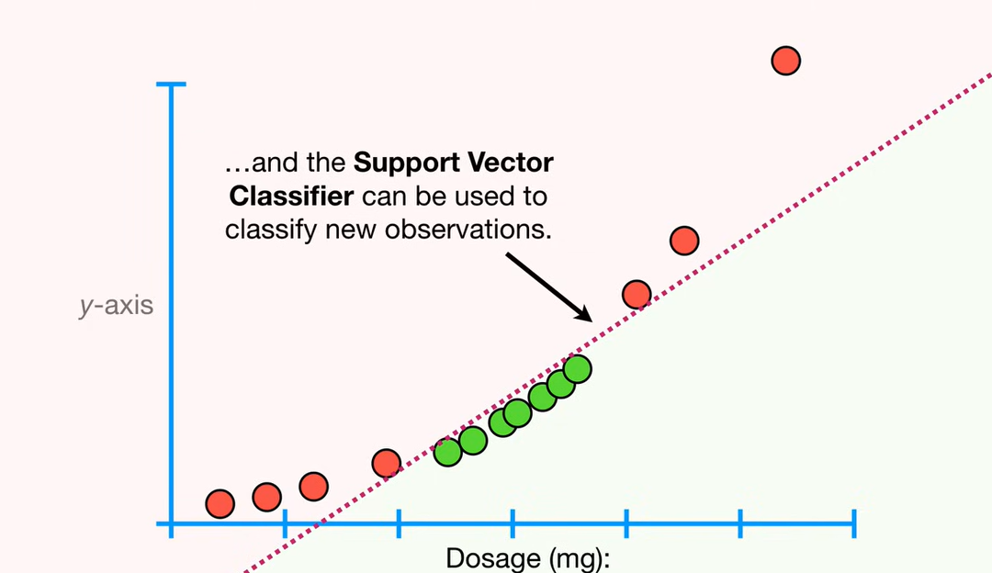

- Main idea: Start with data in a low dimension, move data to a higher dimension, find SVC that divides higher dimension data into 2 groups.
- How do we decide how to transform data? We can use Kernel Functions to systematically find SVC’s in higher dimensions.
  - Kernel Functions don’t convert data to a higher plane, but rather, they make comparisons between observations as if they were, and find the SVC based on these comparisons.
  - Polynomial Kernel: Contains a parameter d, which stands for the degree of the polynomial.

